Data Science Project

Swissgrid single-price mechanism: Could it be profitable to keep open positions?

Conceptual Design Report

21 September 2025

Abstract
To operate electrical machines safely in Europe, the electrical grid should always run at 50 Herz. This frequency can be impacted by production and consumption. When production is higher than consumption, the frequency increases, otherwise it decreases. The Transmission System Operator in Switzerland (Swissgrid) uses ancillary services to keep this frequency as stable as possible. If the grid is not balanced, the TSO will automatically send signals to power assets to adjust their production accordingly. Balance groups are thus financially compensated to balance the grid. On the other hand, they are penalized when they unbalance the grid. To avoid paying penalties, open positions can be closed until 5 minutes before delivery in the intraday market. A common rule is to keep those positions as low as possible. Residual positions can still be exchanged between balance groups a couple of days later during the so-called Post Scheduling Adjustment. However, from 2026, the method to calculate balancing energy prices will change. Balance groups that are in the opposite side from Swissgrid and therefore help to balance the grid will be compensated. The PSA will no longer be used and incentives to keep open positions will rise. This report will try to analyze if this assumption could work and generate additional profits.

Table of Contents
1 Project Objectives 1
2 Methods 2
3 Data 2
4 Metadata 3
5 Data Quality 3
6 Data Flow 4
7 Data Model 4
7.1 Conceptual 4
7.2 Logical 4
7.3 Physical 5
8 Documentation 5
9 Risks 5
10 Preliminary Studies 5
11 Conclusions 6
Statement 6
Appendix 7
References 7

1 Project Objectives
The main goal of every balance group is to keep their positions as balanced as possible to reduce their power balancing costs. The intraday market allows us to close open positions up to 5 minutes before delivery. However, it is not always an easy task. The Swiss market is illiquid and it is not always possible to trade cross-border due to lack of capacity. Sometimes, the prices deviate too much from the spot price and balancing cost could be just cheaper. With the actual dual-price mechanism for balancing energy, balance groups pay penalties whether they were short or long for each hour of a specific day. To minimize those costs, they can still exchange positions with other balance groups. For example, if balance group A is long 5 MW for a specific hour and balance group B is 5 MW short for the same hour, they can exchange this position. Both balance groups are balanced and won’t need to pay any penalties for that hour.
From 2026, a new single-price method will be used to reduce the need of control energy. According to Swissgrid, this new mechanism creates financial incentives for all balance groups to contribute to the balance of the grid [1]. Keeping open positions in the opposite side of Swissgrid will be compensated. Therefore, the PSA will no longer be used. Let’s analyze this example: If Swissgrid is short and a balance group A is long for the same hour, balance group A will be compensated and won’t have any incentive to exchange his position with balance group B, which is short. Balance group B will therefore pay penalties.
It is not easy for a balance group to know its exact intraday position due to poor forecasts. It is even harder to predict the exact position of Swissgrid for the next 60 minutes. However, if one can estimate those two positions in a relatively precise way, it can be tempting to take specific positions in the intraday market or at least to keep already well-known positions. However, a risk remains present: if several balance groups deliberately take positions in a certain way, there is a high probability that Swissgrid will shift in the same way. The balance groups will then pay penalties. It is therefore important to monitor the profits and losses of such activity.
The initial goal of this study is to predict the position of the grid at least one hour before delivery. This can be done by analyzing historical data provided by Swissgrid. Some patterns should be found regarding the side and the depth of the imbalance. In a more advanced way, a machine learning model could also be used. Then, from 2026, the goal will be to keep small positions and determine if those positions will be compensated by Swissgrid. A report will be made to track the Profit and Loss. Eventually, the first analysis will be reconducted to determine how this new price mechanism will affect imbalances.

2 Methods
The following infrastructure and libraries will be used in this projet: Visual Studio Code, Pandas, NumPy, Matplotlib, Scikit-learn.
To forecast Swissgrid’s imbalances for the next two hours as shown in figure below, a simple model based on historical data will be trained and updated continuously. The forecast quality will be evaluated with the imbalance realized. If needed, the model will adjust its initial forecast. That forecast will allow the short-term portfolio manager to have a better understanding of Swissgrid’s position and decide to keep an open position or close it in the intraday market. To trade on the German market, cross-border capacity needs to be booked up to one hour before delivery. That’s the reason behind the need for two hours forecast.

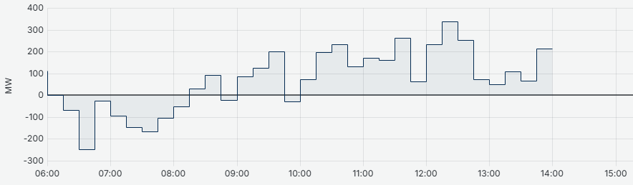
Figure 1: Swissgrid imbalance forecast

Each day, our EDM (Energy Data Management) will provide an excel report on a directory with the data from the day before. This file will be analyzed using a python script to determine the exact imbalances of the balance group and the positions that were kept open. Those data will be compared to the positions of Swissgrid and to the new energy price to determine the profit or loss for each hour.

3 Data
Swissgrid provides a file every 30 minutes as shown on table below. This file contains all the imbalances for the last 24 hours per 15 minutes. The amount of FRC, aFRR and mFRR activated on both sides can also be found. Sometimes, the TSO also must export or import energy in neighboring countries (NRV). As already mentioned, the energy price for 2026 will also be used to calculate the profits and losses.
To balance the grid, Swissgrid forecasts production and consumption by using sophisticated models that consider several parameters such as weather conditions. Unfortunately, they only share they do not share those forecasts to prevent balance groups doing speculative activities on ancillary services.

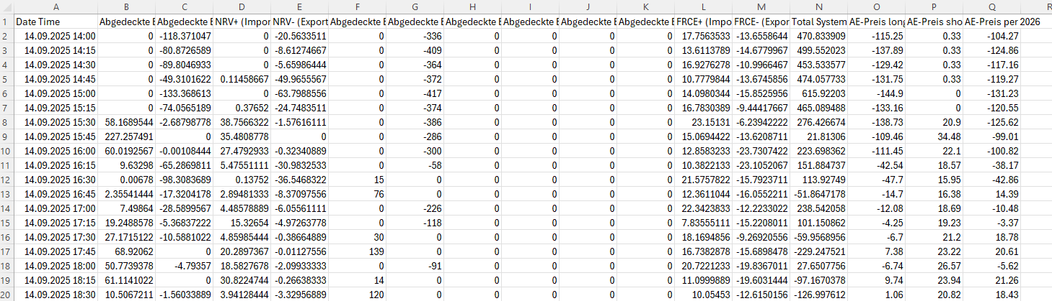
Figure 2: Control Area Balance file from Swissgrid

4 Metadata
The time series that will be used are described in chapter 3. This data includes imbalances and energy prices for the actual dual-price mechanism and the single-price mechanism. It can be consulted on the website of Swissgrid: https://www.swissgrid.ch/en/home/customers/topics/energy-data-ch.html
In that project, the actual data from a real balance group owned by the company FMV SA will not be shared.

5 Data Quality
The data from Swissgrid seems to be excellent. The data should still be cleaned to find and discard any missing values.

6 Data Flow
The following figure shows the data flow:

Figure 3: Data flow

7 Data Model

7.1 Conceptual
At the conceptual level, I describe the idea of the project. With the introduction of the single-price mechanism, potential additional profits can be reached. By forecasting the imbalances, we can keep open positions and be compensated by Swissgrid if our positions help to balance the grid.

7.2 Logical
At the logical level, I describe the specific columns that will be used. From the file from Swissgrid, I will need the timestamp (DateTime), the total imbalance (float) and the price (float). From the file from our EDM, I will need the timestamp (DateTime) and the positions kept open (float).

7.3 Physical
At the physical level, I describe the infrastructure that will be used. The data and models will be processed on our own servers.

8 Documentation
The project will be commented directly on the script on VSCode.

9 Risks
Having a bad forecast could lead to financial penalties. However, even if the forecast is good and all balance groups do the same, the initial side of the grid could change to the opposite side.

10 Preliminary Studies
The plot below shows the average of imbalances for each month per 15 minutes in MW during the last 3 years.
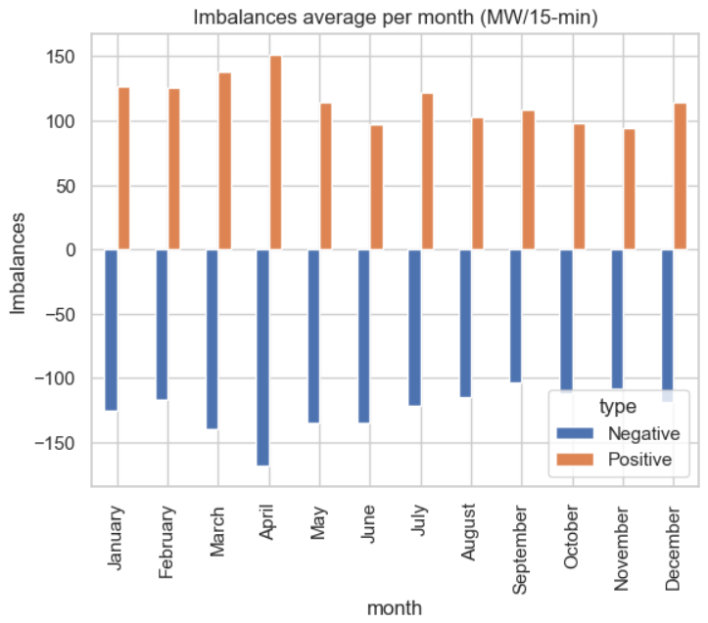
Figure 4: Swissgrid imbalances

11 Conclusions
In this conceptual design report, I outlined that the objective of the study is to know if keeping open positions could be profitable with the new single-price mechanism of Swissgrid. The result will depend on the quality of the forecast but also on the behavior of all the balance groups.

Statement
„Ich erkläre hiermit, dass ich diese Arbeit selbstständig verfasst und keine anderen als die angegebenen Quellen benutzt habe. Alle Stellen, die wörtlich oder sinngemäss aus Quellen entnommen wurden, habe ich als solche gekennzeichnet. Mir ist bekannt, dass andernfalls die Arbeit als nicht erfüllt bewertet wird und dass die Universitätsleitung bzw. der Senat zum Entzug des aufgrund dieser Arbeit verliehenen Abschlusses bzw. Titels berechtigt ist. Für die Zwecke der Begutachtung und der Überprüfung der Einhaltung der Selbstständigkeitserklärung bzw. der Reglemente betreffend Plagiate erteile ich der Universität Bern das Recht, die dazu erforderlichen Personendaten zu bearbeiten und Nutzungshandlungen vorzunehmen, insbesondere die schriftliche Arbeit zu vervielfältigen und dauerhaft in einer Datenbank zu speichern sowie diese zur Überprüfung von Arbeiten Dritter zu verwenden oder hierzu zur Verfügung zu stellen.“
Date: 21.09.2025 Signature(s): 

Appendix
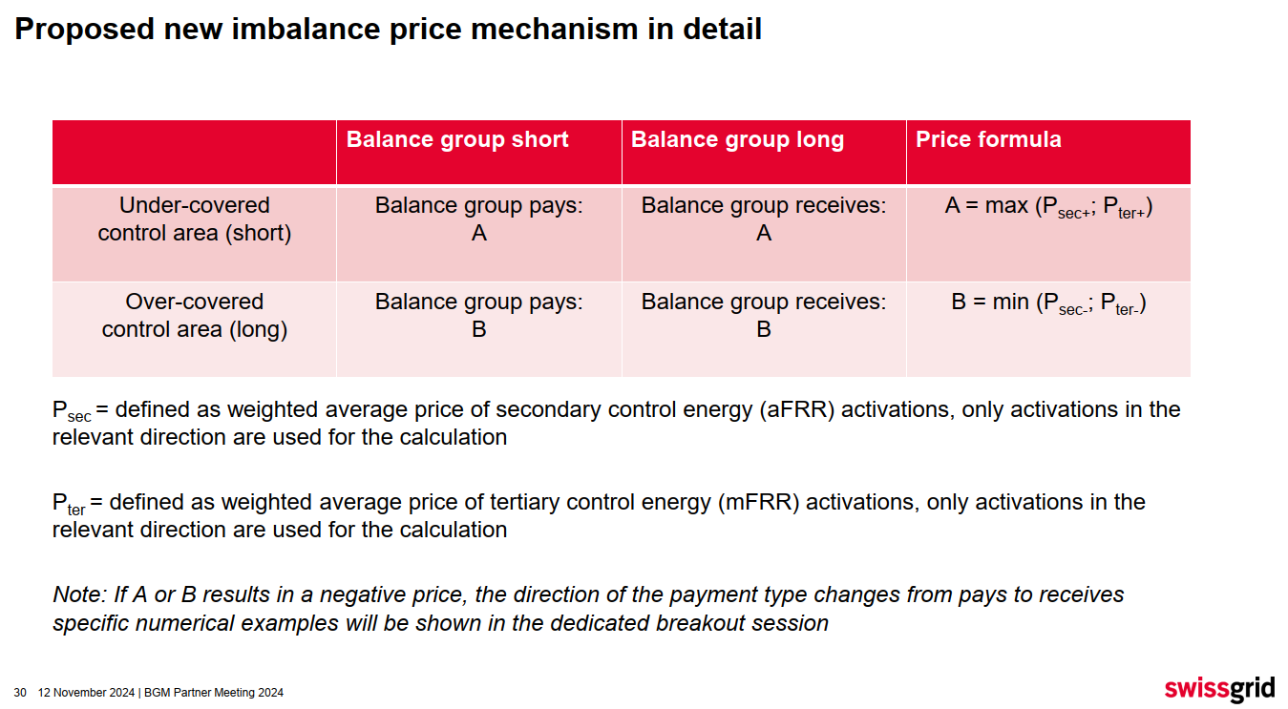
Figure 5: New price mechanism from Swissgrid

References
[1] https://www.swissgrid.ch/en/home/newsroom/newsfeed/20250328-01.html

